McKinsey

Company Challenge: How might we make insurance truly personalized, integrated and easily accessible for younger consumers who may not understand the long-term financial and other benefits of these often complex products?

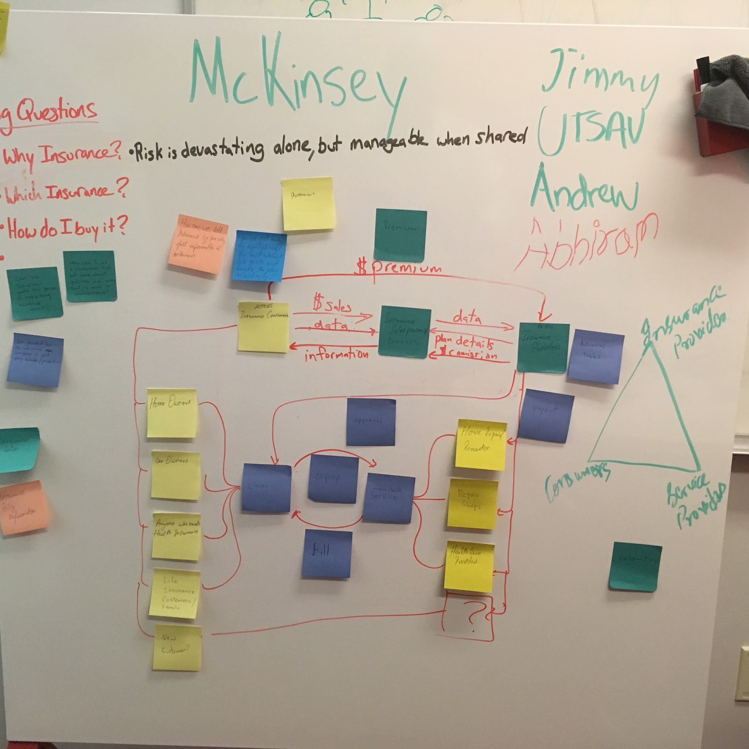

Wedges:

1. Simplicity -- Based on our discussion with Doug McElhenney, our company champion, the insurance industry can offer complicated products and the value is not always clear, even to those who are getting great deals like young people. An insurance product that communicates value to end customers in a very simple and clear way would be extremely valuable.
2. Insurance as a Life Service -- Doug also told us that most insurance companies have only three discussions with their customers: setting up the policy, renegotiating the policy, and fulfilling a claim. He suggests that a service which kept in touch much more frequently, and used their datasets to communicate useful information about your health and risk level, would be much more valuable to the customers.
3. Data Analysis -- Finally, Doug told us that he knows of insurance companies that already collect a tremendous amount of data about their customers’ lives, but don’t do anything with it. A fresh approach to that data could both improve operations within the company, but also offer value to customers.
4. Easier and Faster insurance claim -- We thought of creating a third party insurance claims service which can help customers claim insurance as soon as the accident happens, and not worry about going through the hassle of doing things themselves and putting extra time and effort into this process.

User Stories:

1. As a young person, I want to know why I should even care about insurance.
2. As a company who operates through a website, I want to know that I’ll be ok if I get hacked.
3. As a person with online accounts, I want to know what will happen if my accounts are compromised.
4. As a customer of health insurance, I want to know what I can do to reduce my premium and improve my health.
5. As a customer of health insurance, I want to know what everyone else is doing to take care of their health.
6. As a busy individual, I would like an easy method to claim insurance, or get appraisal for my damages, maybe by hiring someone to do the job for me.